Pass Task 7.1 report

|  |  |
| --- | --- |
| Student Name | Lim Jia Lok |
| Student ID | 101212631 |

## SUB Task 7.1.1

#### Solution

**A. Select all**

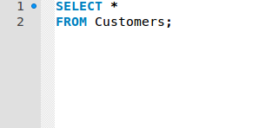

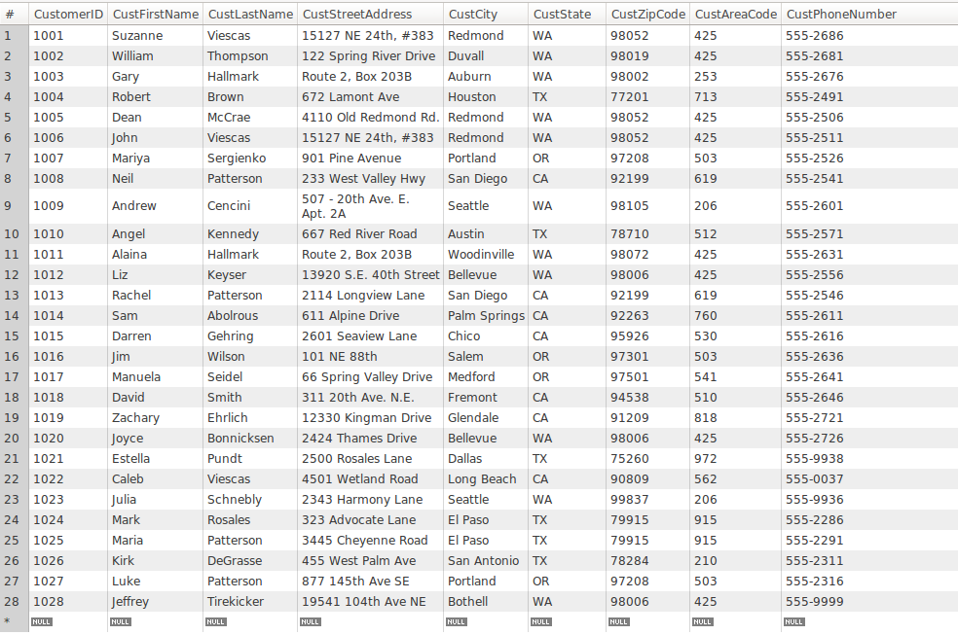

**B. CONCAT**



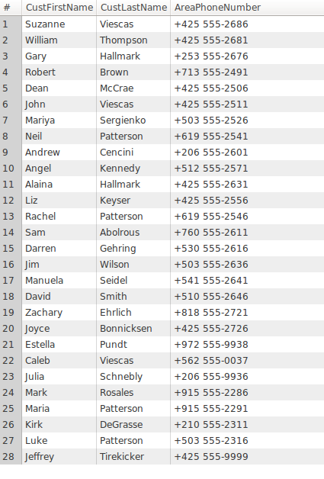

#### Comments/findings

…

## SUB Task 7.1.2

#### Solution

**A. Show Washington State**

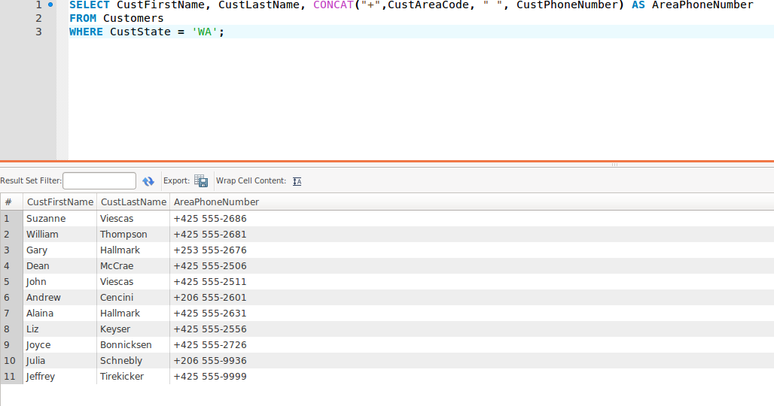

**B. Show Washington State and Oregon**

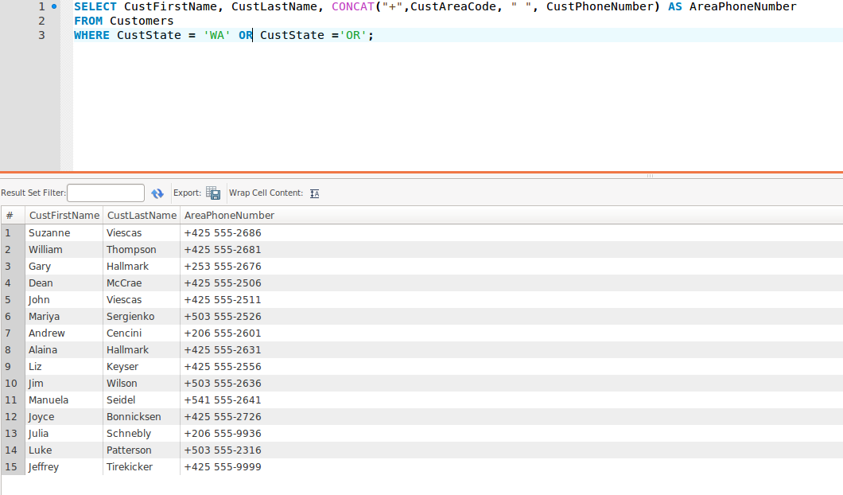

#### Comments/findings

## SUB Task 7.1.3

#### Solution

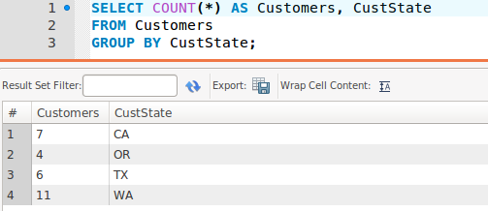

#### Comments/findings

…

(Where applicable)

## SUB Task 7.1.4

#### Solution

**B. Joining customers table and orders table**



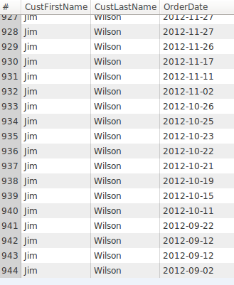

**C. Joining customers table and orders table to include an employee with no order**

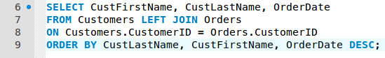

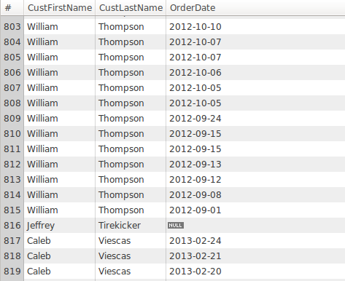

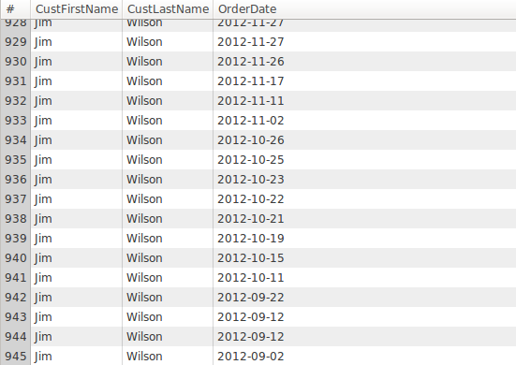

**D. Find customers’s latest order date**

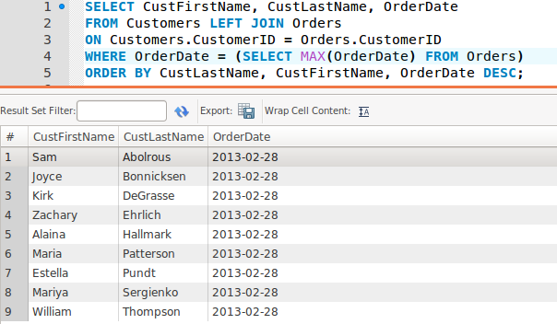

#### Comments/findings

**A. The purpose is to show when customers, using their first and last name, ordered on what date. The row is arranged from the latest order dates to the oldest order dates.**

## SUB Task 7.1.5

#### Solution

**A. Create a view**

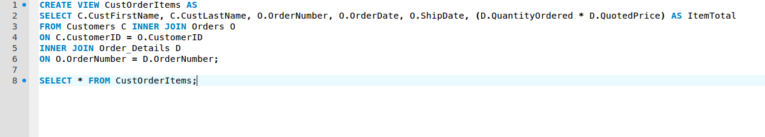

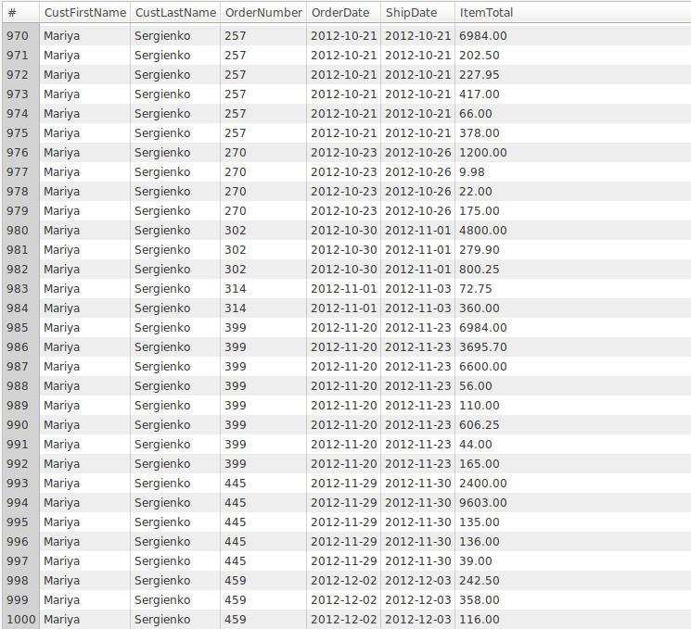

**B. Show OrderTotal from the view**

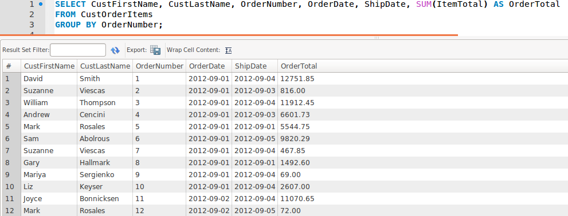

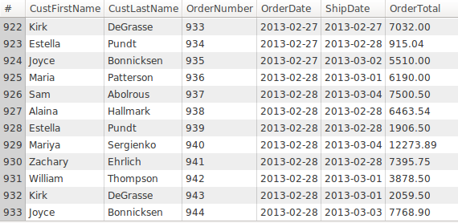

#### Comments/findings

…

(Where applicable)